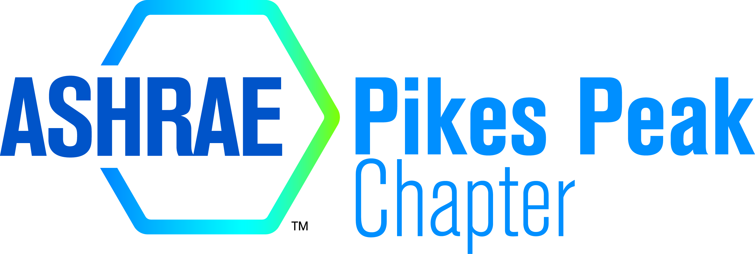
2016 FALL TOURNAMENT

Thursday, August 25 – Arrowhead Golf Club
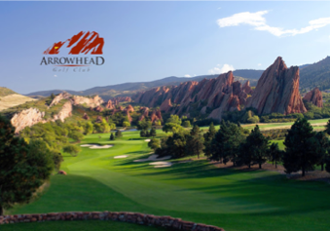
Please visit www.arrowheadcolorado.com for additional information and directions

Check-in: Noon
Start: 1:30 PM

TEE TIME 1:30 P.M. FOUR PERSON SCRAMBLE, TWO FLIGHTS
$150 PER GOLFER - $550 PER FOURSOME - SIGN UP ON http://pikespeakashrae.com/
OR fill out this sheet and mail with check to: Aaron Morris, c/o Long
5260 Mark Dabling Blvd, Colorado Springs, CO 80918
FEE INCLUDES GOLF, CART, RANGE BALLS, ARROWHEAD BAG TAG, AND BANQUET
TWO FLIGHTS OF 1ST & 2ND PRIZE MONEY, Two long drives and closest to the pin prizes on par threes.
HOLE SPONSORSHIPS ($250/hole) ALL PROCEEDS TO ASHRAE RESEARCH IN YOUR NAME – sign up on the web-site, or contact Bradley Grant (bgrant@f-w.com)
Raffle & more Prizes will be announced soon.
You Only Need One Player To Sign-Up:
1.______________________________________ 2. _________________________________________
3.______________________________________ 4. _________________________________________
For information please contact: Darin Amsberry (303-718-4409) damsberry@f-w.com, Ramon Teran (720-281-3142), rt@westernmechanicalsolutions.com, Michael Brubaker ((719) 314-8075), michael.brubaker@ColoradoCollege.edu

